

**C PROGRAMMING LAB**

**DEPARTMENT OF**

**COMPUPER SCIENCE AND ENGINEERING**

**AURORA’S SCINTIFIC, TECHNOLOGICAL AND RESEARCH ACADEMY**

**Bandlaguda, Hyderabad – 500005. Ph: 040 -244440840,65245611**.

**PREFACE**

C is a general-purpose high level language that was originally developed by Dennis Ritchie for the Unix operating system. It was first implemented on the Digital Eqquipment Corporation PDP-11 computer in 1972. The Unix operating system and virtually all Unix applications are written in the C language. C has now become a widely used professional language for various reasons.Easy to learn,Structured language,It produces efficient programs,It can handle low-level activities.It can be compiled on a variety of computers.

**Facts about C**

C was invented to write an operating system called UNIX.

C is a successor of B language which was introduced around 1970

The language was formalized in 1988 by the American National Standard Institue (ANSI).

By 1973 UNIX OS almost totally written in C.

Today C is the most widely used System Programming Language.

Most of the state of the art software have been implemented using C

**Why to use C ?**

C was initially used for system development work, in particular the programs that make-up the operating system. C was adoped as a system development language because it produces code that runs nearly as fast as code written in assembly language. Some examples of the use of C might be:

Operating Systems

Language Compilers

Assemblers

Text Editors

Print Spoolers

Network Drivers

Modern Programs

Data Bases

Language Interpreters

Utilities

**C Program File**

All the C programs are writen into text files with extension ".c" for example ***hello.c***. You can use "vi" editor to write your C program into a file. This tutorial assumes that you know how to edit a text file and how to write programming insturctions inside a program file.

**C Compilers**

When you write any program in C language then to run that program you need to compile that program using a C Compiler which converts your program into a language understandable by a computer. This is called machine language (ie. binary format). So before proceeding, make sure you have C Compiler available at your computer. It comes alongwith all flavors of Unix and Linux. If you are working over Unix or Linux then you can type *gcc -v* or *cc -v* and check the result. You can ask your system administrator or you can take help from anyone to identify an available C Compiler at your computer.

If you don't have C compiler installed at your computer then you can use below given link to download a GNU C Compiler and use it.2

**INDEX**

|  |  |  |
| --- | --- | --- |
| **S. No** | **Content** | **Page no** |
| **1** | Preface | **2** |
| **2** | Objective and Relevance | **4** |
| **3** | Outcomes | **5** |
| **4** | Code Of Conduct | **6** |
| **5** | List Of Experiments | **9** |
| **6** | Syllabus analysis | **12** |
| **7** | Session Plan | **16** |
| **8** | Equipment Required | **19** |
| **9** | Experiment Write Up | **26** |

1. **Objective and Relevance**

* To review basic computer systems concepts
* To be able to understand the different computing environments and their components
* To review the history of computer languages
* To be able to list and describe the classifications of computer languages
* To understand the steps in the development of a computer program To review the system development life cycle
* To write programs in C to solve the problems.
* To implement linear data structures such as lists, stacks, queues.
* To implement simple searching and sorting methods.

1. **Outcomes**

|  |
| --- |
|  |

|  |
| --- |
| * 1: This subject contributes to having students practice their writing skills with project document and report writing. * 2: This subject contributes to developing student critical thinking through tutorial and lab exercises on solving problems. They will also practice more in written assignments, programming exercises, and project. * 3: This subject contributes to team work with group-based project for students to practice team spirit. |
|  |

1. **CODE OF CONDUCT**

* Students should report to the labs concerned as per the timetable.
* Students who turn up late to the labs will in no case be permitted to perform the experiment scheduled for the day.
* After completion of the experiment, certification of the staff in-charge concerned in the observation book is necessary.
* Students should bring a notebook of about 100 pages and should enter the readings/observations/results into the notebook while performing the experiment.
* The record of observations along with the detailed experimental procedure of the experiment performed in the immediate previous session should be submitted and certified by the staff member in-charge.
* Not more than three students in a group are permitted to perform the experiment on a set up.
* The group-wise division made in the beginning should be adhered to, and no mix up of student among different groups will be permitted later.
* The components required pertaining to the experiment should be collected from Lab- in-charge after duly filling in the requisition form.
* When the experiment is completed, students should disconnect the setup made by them, and should return all the components/instruments taken for the purpose.
* Any damage of the equipment or burnout of components will be viewed seriously either by putting penalty or by dismissing the total group of students from the lab for the semester/year.
* Students should be present in the labs for the total scheduled duration.
* Students are expected to prepare thoroughly to perform the experiment before coming to Laboratory.
* Procedure sheets/data sheets provided to the students’ groups should be maintained neatly and are to be returned after the experiment.

1. **LIST OF EXPERIMENTS)SYLLBUS AS PER JNTUH**

**Week l**

a) Write a C program to find the sum of individual digits of a positive integer.

b) A Fibonacci sequence is defined as follows: the first and second terms in the sequence are 0 and 1. Subsequent terms are found by adding the preceding two terms in the sequence. Write a C program to generate the first n terms of the sequence.

c) Write a C program to generate all the prime numbers between 1 and n, where n is a value supplied by the user.

**Week 2**

a) Write a C program to calculate the following Sum:

Sum=1-x2/2! +x4/4!-x6/6!+x8/8!-x10/10!

b) Write a C program to find the roots of a quadratic equation.

**Week 3**

a) The total distance travelled by vehicle in ‘t’ seconds is given by distance = ut+1/2at2 where ‘u’ and ‘a’ are the initial velocity (m/sec.) and acceleration (m/sec2). Write C program to find the distance travelled at regular intervals of time given the values of ‘u’ and ‘a’. The program should provide the flexibility to the user to select his own time intervals and repeat the calculations for different values of ‘u’ and ‘a’.

b) Write a C program, which takes two integer operands and one operator from the user, performs the operation and then prints the result. (Consider the operators +,-,*, /, % and use Switch Statement)

**Week 4**

a) Write C programs that use both recursive and non-recursive functions

i) To find the factorial of a given integer.

ii) To find the GCD (greatest common divisor) of two given integers.

**Week 5**

a) Write a C program to find the largest integer in a list of integers.

b) Write a C program that uses functions to perform the following:

i) Addition of Two Matrices

ii) Multiplication of Two Matrices

**Week 6**

a) Write a C program that uses functions to perform the following operations:

i) To insert a sub-string in to a given main string from a given position.

ii) To delete n Characters from a given position in a given string.

b) Write a C program to determine if the given string is a palindrome or not

**Week 7**

a) Write a C program that displays the position or index in the string S where the string T begins, or – 1 if S doesn’t contain T.

b) Write a C program to count the lines, words and characters in a given text.

**Week 8**

a) Write a C program to generate Pascal’s triangle.

b) Write a C program to construct a pyramid of numbers.

**Week 9**

Write a C program to read in two numbers, x and n, and then compute the sum of this geometric progression: 1+x+x2+x3+………….+xn For example: if n is 3 and x is 5, then the program computes 1+5+25+125.Print x, n, the sum Perform error checking. For example, the formula does not make sense for negative exponents – if n is less than 0.Have your program print an error message if n<0, then go back and read in the next pair of numbers of without computing the sum. Are any values of x also illegal? If so, test for them too.

**Week 10**

a) 2’s complement of a number is obtained by scanning it from right to left and complementing all the bits after the first appearance of a 1. Thus 2’s complement of 11100 is 00100. Write a C program to find the 2’s complement of a binary number.

b) Write a C program to convert a Roman numeral to its decimal equivalent.

**Week 11**

Write a C program that uses functions to perform the following operations:

i) Reading a complex number

ii) Writing a complex number

iii) Addition of two complex numbers

iv) Multiplication of two complex numbers

(Note: represent complex number using a structure.)

**Week 12**

a) Write a C program which copies one file to another.

b) Write a C program to reverse the first n characters in a file.

(Note: The file name and n are specified on the command line.)

**Week 13**

a) Write a C program to display the contents of a file.

b) Write a C program to merge two files into a third file (i.e., the contents of the first file

followed by those of the second are put in the third file)

**Week 14**

a) Write a C program that uses non recursive function to search for a Key value in a given list of integers using Linear search.

b) Write a C program that uses non recursive function to search for a Key value in a given sorted list of integers using Binary search.

**Week 15**

a) Write a C program that implements the Selection sort method to sort a given array of integers

in ascending order.

b) Write a C program that implements the Bubble sort method to sort a given list of names

in ascending order.

**Week 16**

Write a C program that uses functions to perform the following operations:

i) Create a singly linked list of integer elements.

ii) Traverse the above list and display the elements.

**Week 17**

Write a C program that implements stack (its operations) using a singly linked list to display

a given list of integers in reverse order. Ex. input: 10 23 4 6 output: 6 4 23 10

**Week 18**

Write a C program that implements Queue (its operations) using a singly linked list to display

a given list of integers in the same order. Ex. input: 10 23 4 6 output: 10 23 4 6

**Week 19**

Write a C program to implement the linear regression algorithm.

**Week 20**

Write a C program to implement the polynomial regression algorithm.

**Week 21**

Write a C program to implement the Lagrange interpolation.

**Week 22**

Write C program to implement the Newton- Gregory forward interpolation.

**Week 23**

Write a C program to implement Trapezoidal method.

**Week 24**

Write a C program to implement Simpson method.

**TEXT BOOKS:**

1. C programming and Data Structures, P. Padmanabham, Third Edition, BS Publications

2. Computer Programming in C, V. Rajaraman, PHI Publishers.

3. C Programming, E.Balagurusamy, 3rd edition, TMH Publishers.

4. C Programming, M.V.S.S.N.Prasad, ACME Learning Pvt. Ltd.

5. C and Data Structures, N.B.Venkateswarlu and E.V.Prasad,S.Chand Publishers

6. Mastering C, K.R. Venugopal and S.R. Prasad, TMH Publishers

**6 Syllabus analysis**

|  |  |  |  |
| --- | --- | --- | --- |
| **S.No** | **Name of the Experiment** | **Unit No** | **Text /Reference Books** |
| 1 | a) Write a C program to find the sum of individual digits of a positive integer.  b) A Fibonacci sequence is defined as follows: the first and second terms in the sequence are 0 and 1. Subsequent  terms are found by adding the preceding two terms in the sequence. Write a C program to generate the first n terms  of the sequence.  c) Write a C program to generate all the prime numbers between 1 and n, where n is a value supplied by the user. | 1 |  |
| 2 | a) Write a C program to calculate the following Sum:  Sum=1-x2/2! +x4/4!-x6/6!+x8/8!-x10/10!  b) Write a C program to find the roots of a quadratic equation. | 1 |  |
| 3 | a) The total distance travelled by vehicle in ‘t’ seconds is given by distance = ut+1/2at2 where ‘u’ and ‘a’ are the initial velocity (m/sec.) and acceleration (m/sec2). Write C program to find the distance travelled at regular intervals of time given the values of ‘u’ and ‘a’. The program should provide the flexibility to the user to select his own time intervals and repeat the calculations for different values of ‘u’ and ‘a’.  b) Write a C program, which takes two integer operands and one operator from the user, performs the operation and then prints the result. (Consider the operators +,-,*, /, % and use Switch Statement) | 1 |  |
| 4 | a) Write C programs that use both recursive and non-recursive functions  i) To find the factorial of a given integer.  ii) To find the GCD (greatest common divisor) of two given integers. | 2 |  |
| 5 | a) Write a C program to find the largest integer in a list of integers.  b) Write a C program that uses functions to perform the following:  i) Addition of Two Matrices  ii) Multiplication of Two Matrices | 2 |  |
| 6 | a) Write a C program that uses functions to perform the following operations:  i) To insert a sub-string in to a given main string from a given position.  ii) To delete n Characters from a given position in a given string.  b) Write a C program to determine if the given string is a palindrome or not | 2 |  |
| 7 | a) Write a C program that displays the position or index in the string S where the string T begins, or – 1 if S doesn’t contain T.  b) Write a C program to count the lines, words and characters in a given text | 3 |  |
| 8 | a) Write a C program to generate Pascal’s triangle.  b) Write a C program to construct a pyramid of numbers | 3 |  |
| 9 | Write a C program to read in two numbers, x and n, and then compute the sum of this geometric progression: 1+x+x2+x3+………….+xn For example: if n is 3 and x is 5, then the program computes 1+5+25+125.Print x, n, the sum Perform error checking. For example, the formula does not make sense for negative exponents – if n is less than 0.Have your program print an error message if n<0, then go back and read in the next pair of numbers of without computing the sum. Are any values of x also illegal? If so, test for them too. | 3 |  |
| 10 | a) 2’s complement of a number is obtained by scanning it from right to left and complementing all the bits after the first appearance of a 1. Thus 2’s complement of 11100 is 00100. Write a C program to find the 2’s complement of a binary number.  b) Write a C program to convert a Roman numeral to its decimal equivalent | 3 |  |
| 11 | Write a C program that uses functions to perform the following operations:  i) Reading a complex number  ii) Writing a complex number  iii) Addition of two complex numbers  iv) Multiplication of two complex numbers  (Note: represent complex number using a structure.) | 3 |  |
| 12 | a) Write a C program which copies one file to another.  b) Write a C program to reverse the first n characters in a file.(Note: The file name and n are specified on the command line.) | 4 |  |
| 13 | a) Write a C program to display the contents of a file.  b) Write a C program to merge two files into a third file (i.e., the contents of the first filefollowed by those of the second are put in the third file) | 4 |  |
| 14 | a) Write a C program that uses non recursive function to search for a Key value in a given list of integers using Linear search.  b) Write a C program that uses non recursive function to search for a Key value in a given sorted list of integers using Binary search. | 3 |  |
| 15 | a) Write a C program that implements the Selection sort method to sort a given array of integers  in ascending order.  b) Write a C program that implements the Bubble sort method to sort a given list of names  in ascending order. | 5 |  |
| 16 | C program that uses functions to perform the following operations:  i) Create a singly linked list of integer elements.  ii) Traverse the above list and display the elements. | 5 |  |
| 17 | implements stack (its operations) using a singly linked list to display a given list of integers in reverse order | 5 |  |
| 18 | implements Queue (its operations) using a singly linked list to display a given list of integers in the same order | 5 |  |
| 19 | Write a C program to implement the linear regression algorithm | 5 |  |
| 20 | Write a C program to implement the polynomial regression algorithm. | 5 |  |
| 21 | Write a C program to implement the Lagrange interpolation | 5 |  |
| 22 | Write C program to implement the Newton- Gregory forward interpolation | 5 |  |
| 23 | Write a C program to implement Trapezoidal method | 5 |  |
| 24 | Write a C program to implement Simpson method. | 5 |  |

7. SESSION PLAN

|  |  |  |  |  |
| --- | --- | --- | --- | --- |
| SL.NO | Week no. | Unit no. | Activity | Remarks |
| 1 | 1 | 1 | a) Write a C program to find the sum of individual digits of a positive integer.  b) A Fibonacci sequence is defined as follows: the first and second terms in the sequence are 0 and 1. Subsequent  terms are found by adding the preceding two terms in the sequence. Write a C program to generate the first n terms  of the sequence.  c) Write a C program to generate all the prime numbers between 1 and n, where n is a value supplied by the user. | Prerequisite |
| 2 | 2 | 1 | a) Write a C program to calculate the following Sum:  Sum=1-x2/2! +x4/4!-x6/6!+x8/8!-x10/10!  b) Write a C program to find the roots of a quadratic equation. | JNTUH |
| 3 | 3 | 1 | a) The total distance travelled by vehicle in ‘t’ seconds is given by distance = ut+1/2at2 where ‘u’ and ‘a’ are the initial velocity (m/sec.) and acceleration (m/sec2). Write C program to find the distance travelled at regular intervals of time given the values of ‘u’ and ‘a’. The program should provide the flexibility to the user to select his own time intervals and repeat the calculations for different values of ‘u’ and ‘a’.  b) Write a C program, which takes two integer operands and one operator from the user, performs the operation and then prints the result. (Consider the operators +,-,*, /, % and use Switch Statement) | JNTUH |
| 4 | 4 | 2 | a) Write C programs that use both recursive and non-recursive functions  i) To find the factorial of a given integer.  ii) To find the GCD (greatest common divisor) of two given integers. | JNTUH |
| 5 | 5 | 2 | a) Write a C program to find the largest integer in a list of integers.  b) Write a C program that uses functions to perform the following:  i) Addition of Two Matrices  ii) Multiplication of Two Matrices | JNTUH |
| 6 | 6 | 2 | a) Write a C program that uses functions to perform the following operations:  i) To insert a sub-string in to a given main string from a given position.  ii) To delete n Characters from a given position in a given string.  b) Write a C program to determine if the given string is a palindrome or not | JNTUH |
| 7 | 7 | 3 | a) Write a C program that displays the position or index in the string S where the string T begins, or – 1 if S doesn’t contain T.  b) Write a C program to count the lines, words and characters in a given text | JNTUH |
| 8 | 8 | 3 | a) Write a C program to generate Pascal’s triangle.  b) Write a C program to construct a pyramid of numbers | JNTUH |
| 9 | 9 | 3 | Write a C program to read in two numbers, x and n, and then compute the sum of this geometric progression: 1+x+x2+x3+………….+xn For example: if n is 3 and x is 5, then the program computes 1+5+25+125.Print x, n, the sum Perform error checking. For example, the formula does not make sense for negative exponents – if n is less than 0.Have your program print an error message if n<0, then go back and read in the next pair of numbers of without computing the sum. Are any values of x also illegal? If so, test for them too. | JNTUH |
| 10 | 10 | 3 | a) 2’s complement of a number is obtained by scanning it from right to left and complementing all the bits after the first appearance of a 1. Thus 2’s complement of 11100 is 00100. Write a C program to find the 2’s complement of a binary number.  b) Write a C program to convert a Roman numeral to its decimal equivalent | JNTUH |
| 11 | 11 | 3 | Write a C program that uses functions to perform the following operations:  i) Reading a complex number  ii) Writing a complex number  iii) Addition of two complex numbers  iv) Multiplication of two complex numbers  (Note: represent complex number using a structure.) | JNTUH |
| 12 | 12 | 4 | a) Write a C program which copies one file to another.  b) Write a C program to reverse the first n characters in a file.(Note: The file name and n are specified on the command line.) | JNTUH |
| 13 | 13 | 4 | a) Write a C program to display the contents of a file.  b) Write a C program to merge two files into a third file (i.e., the contents of the first filefollowed by those of the second are put in the third file) | JNTUH |
| 14 | 14 | 3 | a) Write a C program that uses non recursive function to search for a Key value in a given list of integers using Linear search.  b) Write a C program that uses non recursive function to search for a Key value in a given sorted list of integers using Binary search. | JNTUH |
| 15 | 15 | 5 | a) Write a C program that implements the Selection sort method to sort a given array of integers  in ascending order.  b) Write a C program that implements the Bubble sort method to sort a given list of names  in ascending order. | JNTUH |
| 16 | 16 | 5 | C program that uses functions to perform the following operations:  i) Create a singly linked list of integer elements.  ii) Traverse the above list and display the elements. | JNTUH |
| 17 | 17 | 5 | implements stack (its operations) using a singly linked list to display a given list of integers in reverse order | JNTUH |
| 18 | 18 | 5 | implements Queue (its operations) using a singly linked list to display a given list of integers in the same order | JNTUH |
| 19 | 19 | 5 | Write a C program to implement the linear regression algorithm | JNTUH |
| 20 | 20 | 5 | Write a C program to implement the polynomial regression algorithm. | JNTUH |
| 21 | 21 | 5 | Write a C program to implement the Lagrange interpolation | JNTUH |
| 22 | 22 | 5 | Write C program to implement the Newton- Gregory forward interpolation | JNTUH |
| 23 | 23 | 5 | Write a C program to implement Trapezoidal method | JNTUH |
| 24 | 24 | 5 | Write a C program to implement Simpson method. | JNTUH |

**8. Equipment Required**

**Hardware**

No. of System                         :           60(IBM)

Processor                                 :           PIV™ 1.67 GHz

RAM                                       :           512 MB

Hard Disk                               :           40 GB

Mouse                                     :           Optical Mouse

Network Interface card          :           Present

**Software**

Operating System                   :           Window XP

Application Software              :           Turbo C.

Office                                      :           Ms-Office-2007

**9. Experimental Write Up**

**9.1 Introduction**

**How To Open Application**



Step 1: Open Command Prompt Window

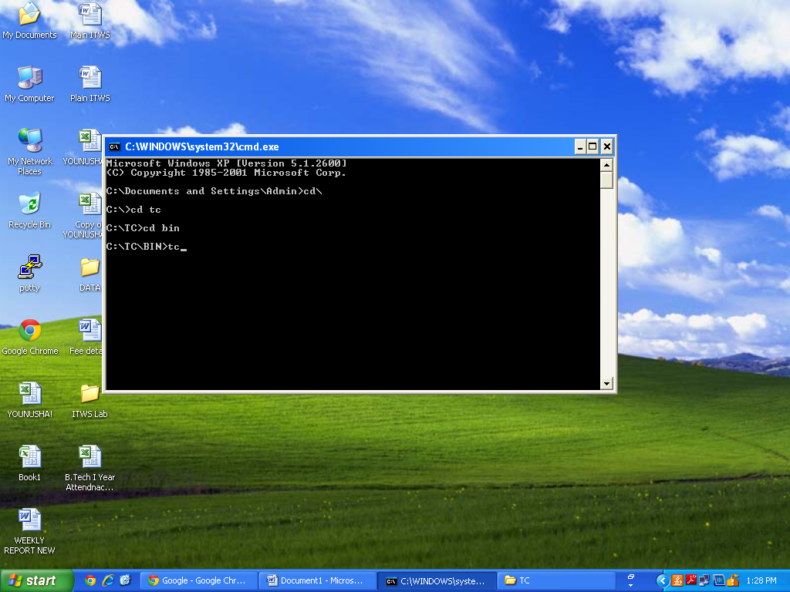

Step 2: Open TC With Command Prompt Window

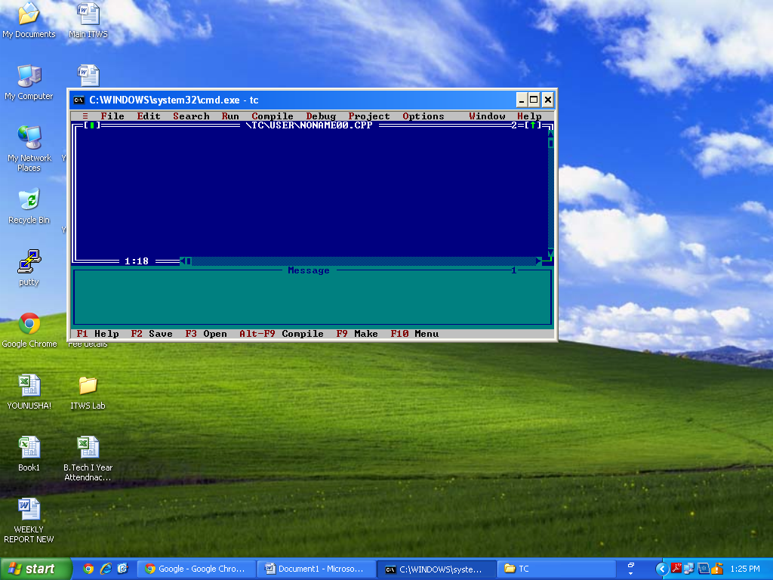

#include

void main()

{

printf("Hello World\n");

printf("Thank You");

getch();

}

I hope that’s enough for a basic explanation of the program. If you still have doubts please ask through comments. Now lets**RUN this program using Turbo C**. Before going into the steps, you may SAVE your C program. Select**“File”** from menu -> click-> **Save**. Name the files as ->**hello.c** or some other name with a .c extension. See the screen shot below.

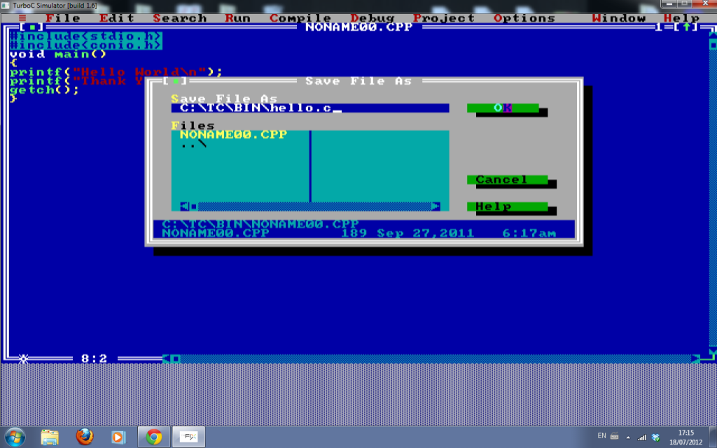

**How to Compile a C program in Turbo C**

**The first step is compiling.** Compiling makes sure your program is **free of syntax errors**. How ever compiler won’t check for any logical/algorithmic errors. There is a lot of process that happens while the compiler compiles a program – which we will discuss later in coming articles. To do compiling -**Select -> Compile** from menu and**click-> compile**. See the image below.

[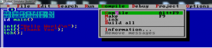](http://www.circuitstoday.com/wp-content/uploads/2012/07/hello-2.png)

After compiling, you will see a dialog box as shown below.If the compilation is success – you will see a**“success”** message. Else you will see the number of errors. Both are shown using screen shots.

**The screen shot of a “success” compilation**

[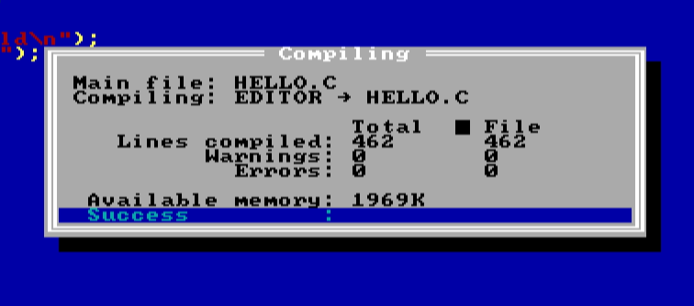](http://www.circuitstoday.com/wp-content/uploads/2012/07/hello-3.png)

**How to RUN a C Program in Turbo C compiler?**

To RUN the program – you may **select ->Run** from menu and**click -> Run** (as shown in the image below).

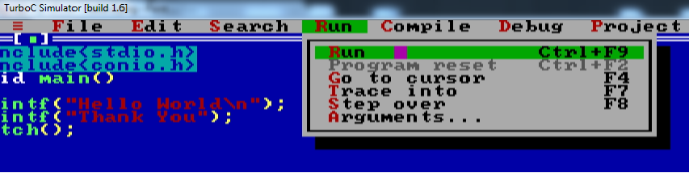

**Now you will see the output screen as shown in the screen shot below.**

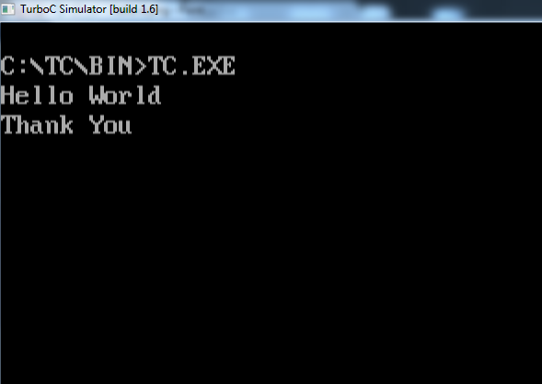

**1a) Write a C program to find the sum of individual digits of a positive integer.**

#include<stdio.h>

#include<conio.h>

void main()

{

int num, k=1, sum=0;

clrscr();

printf(“Enter the number whose digits are to be added:”);

scanf(“%d”,&num);

while(num!=0)

{

k=num%10;

sum=sum+k;

k=num/10;

num=k;

}

printf(“Sum of the digits:%d”,sum);

getch();

}

**Result:**

Enter any integer: 1234

Sum of individual digits is: 10

**SCREEN SHOT**

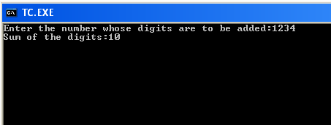

**VIVA QUESTIONS:**

1.What is the mean of sum of the individual digits?

2. What is positive integer?3. Define preprocessor ?

.

**1b) A Fibonacci sequence is defined as follows: the first and second terms in the sequence are 0 and 1. Subsequent terms are found by adding the preceding two terms in the sequence. Write a C program to generate the first n terms of the sequence.**

#include<stdio.h>

#include<conio.h>

void main()

{

int a=0,b=1,c,n,i;

clrscr();

printf(“Enter no. of terms:”);

scanf(“%d”, &n);

printf(“The Fibonacci sequence is:”);

printf(“%d%d”, a,b);

for(i=3;i<=n;i++)

{

c=a+b;

printf(“%d”,c);

a=b;

b=c;

}

getch();

}

**Result:**

Enter no of items: 5

The Fibonacci sequence is

0 1 1 2 3

**SCREEN SHOTS**

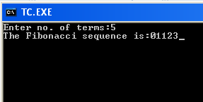

**VIVA QUESTIONS**

1. What is Fibonacci series ?

2) What are the various types of unconditional statements?

3)What are the various types of conditional statements?

4) Expand <STDIO.H >?

1c**) Write a C program to generate all the prime numbers between 1 and n, where n is a value supplied by the user.**

#incloude<stdio.h>

#Include<conio.h>

void main()

{

int i, j, n, count=0;

clrscr();

printf(“Enter the limit:”);

scanf(“%d”, &n);

printf(“The prime numbers are:”);

for(i=2;i<=n;i++)

{

for(j=1;j<=i;j++)

{

if(i%j==0)

count++;

}

if(count==2)

printf(“%d\t”, i);

}getch();

}

**Result:** Enter the linit: 4

The prime numbers are:

2 3 5 7

**SCREEN SHOT**

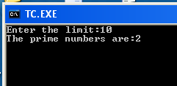

**VIVA QUESTIONS**

1) What is prime number ?

2)What is an algorithm?

3)What is flow chart?

4)What is program?

**2a) Write a C program to calculate the following Sum:**

**Sum=1-x2/2! +x4/4!-x6/6!+x8/8!-x10/10!**

#include<stdio.h>

#include<conio.h>

#include<math.h>

void main()

{

int i,n=10,x;

long int fact=1;

float sum=1;

printf(“Enter the x value:”);

scanf(“%d”, &x);

for(i=1;i<=n;i++)

{

fact=fact*i;

if(i%2==0)

{

if(i==2||i=10||i==6)

sum+= -pow(x,i)/fact;

else

sum+=pow(x,i)/fact;

}

}

Printf(“sum is %f”, sum);

}

**Result:**

Enter x value: 2

Sum is: 0

**SCREEN SHOTS**

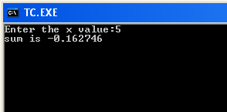

**VIVA QUESTIONS**

1) What are various types of loop statements?

2) What is the difference between while and do-while statements?

3) How to find the roots of qudratric equtations ?

4) List out the C features ?

**2b) Write a C program to find the roots of a quadratic equation.**

#include<stdio.h>

#include<conio.h>

#include<math.h>

void main()

{

float a,b,c,d,r1,r2,imp,rp;

clrscr();

printf(“Enter a,b,c:”);

scanf(“%f%f%f”,&a,&b,&c);

d=b*b-4.0*a*c;

if(d= =0)

{

Printf(“roots are real and equal”);

r1=-b/2*a;

r2=r1;

printf(“root1=%f”,r1);

printf(“root2=%f”,r2);

}

else if(d>0)

{

Printf(“roots are real and unequal”);

r1=(-b+sqrt(d))/2*a;

r2=(-b-sqrt(d))/2*a;

printf(“root1=%f”,r1);

printf(“root2=%f”,r2);

}

else if(d<0)

{

d=-d;

printf(“roots are complex”);

rp=-b/2*a;

imp=sqrt(d)/2*a;

printf(“root1=%f+i%f”,rp,imp);

printf(“root2=%f-i%f”,rp,imp);

}

getch();

}

**Result:**

Enter a,b & c: 1 5 3

Roots are real & unequal

**SCREEN SHOTS**

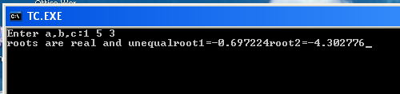

**VIVA Questions**

1) What are various types of loop statements?

2) What is the difference between while and do-while statements?

3) How to find the roots of qudratric equtations ?

4) List out the C features ?

**3a) The total distance travelled by vehicle in ‘t’ seconds is given by distance = ut+1/2at2 where ‘u’ and ‘a’ are the initial velocity (m/sec.) and acceleration (m/sec2). Write C program to find the distance travelled at regular intervals of time given the values of ‘u’ and ‘a’. The program should provide the flexibility to the user to select his own time intervals and repeat the calculations for different values of ‘u’ and ‘a’.**

#include<stdio.h>

#include<conio.h>

#include<math.h>

main()

{

int u,t1,t2,a;

float s=0;

printf("enter initial velocity");

scanf("%d",&u);

printf("enter acceleration");

scanf("%d",&a);

printf("enter time interval t1 & t2");

scanf("%d%d",&t1,&t2);

s=(u*(t1-t2)+(float)(0.5*a*pow((t1-t2),2)));

printf("the distance travelled is:%f",s);

getch();

}

**Output:**

enter u: 2

enter a: 4

enter t1 & t2:

4 2

distance traveeled is:8.00

**SCREEN SHOT**

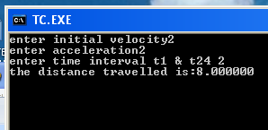

**VIVA QUESTIONS**

1) What is function ?

2) What is procedure ?

3) What are the basic data types in C ?

4) How to define preprocessor ?

**3b) Write a C program, which takes two integer operands and one operator from the user, performs the operation and then prints the result. (Consider the operators +,-,*, /, % and use Switch Statement)**

#include<stdio.h>

#include<conio.h>

main()

{

char ch;

int a,b;

float r=0;

clrscr();

printf("enter a & b");

scanf("%d%d",&a,&b);

flushall();

printf("enter + for add,- for substraction,* for multiplication & / for div");

scanf("%c",&ch);

switch(ch)

{

case '+': r=a+b;

break;

case '-': r=a-b;

break;

case '*': r=a*b;

break;

case '/': r=(float)a/b;

break;

default: printf("enter valid option");

}

printf("result is:%f",r);

getch();

}

**Result:**

enter a & b: 6 2

enter + for add,- for substraction,* for multiplication & / for div +

result is:8.00



**4. Write C programs that use both recursive and non-recursive functions**

**i) To find the factorial of a given integer.**

**ii) To find the GCD (greatest common divisor) of two given integers.**

#include<stdio.h>

#include<conio.h>

unsigned int factorial(int n);

void main()

{

int n,i;

long int fact;

clrscr();

printf("Enter the number: ");

scanf("%d",&n);

if(n==0)

printf("Factorial of 0 is 1\n");

else

printf("Factorial of %d Using Recursive Function is %d\n",n,factorial(n));

getch();

}

/* Recursive Function*/

unsigned int factorial(int n)

{

return n>=1 ? n * factorial(n-1) : 1;

}

**Result:**

Enter number: 5

Factorial of 5 using recursive function is: 120

**SCREEN SHOTS**

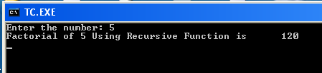

**VIVA QUESTIONS:**

1.What is Fibonacci series ?

2. What are the various types of unconditional statements?3. What are the various types of conditional statements?

4. Expand <STDIO.H >?

**ii.program**

#include<stdio.h>

#include<conio.h>

#include<math.h>

unsigned int GCDRecursive(unsigned m, unsigned n);

int main(void)

{

int a,b;

clrscr();

printf("Enter the two numbers whose GCD is to be found: ");

scanf("%d%d",&a,&b);

printf("GCD of %d and %d Using Recursive Function is %d\n",a,b,GCDRecursive(a,b));

getch();

}

/* Recursive Function*/

unsigned int GCDRecursive(unsigned m, unsigned n)

{

if(n>m)

return GCDRecursive(n,m);

if(n==0)

return m;

else

return GCDRecursive(n,m%n);

}

**Result:**

Enter the two numbers whose GCD is to be found 18 6

GCD of 18 and 6 Using Recursive Function is 6

**SCREEN SHOTS**

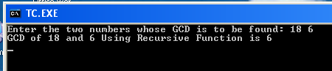

**VIVA QUESTIONS**

1) What is meaning of GCD ?

2) Define scope of a variable ?

3) Show an scope resolution operator ?

4) Define extent of a variable ?

**5a) Write a C program to find the largest integer in a list of integers.**

#include <stdio.h>

#include <conio.h>

main()

{

int i,n,small=0,large=0;

int a[30];

clrscr();

printf("\n Enter size of the array:");

scanf("%d",&n);

printf("\n Enter values in array elements:");

for(i=0;i<n;i++)

{

scanf("%d",&a[i]);

}

small = a[0];

for(i=0;i<n;i++)

{

if(small > a[i])

small = a[i];

}

printf("\n The smallest element in given array is %d",small);

large=0;

for(i=0;i<n;i++)

{

if(large < a[i])

large = a[i];

}

printf("\n The largest element in given array is %d",large);

printf("\n :End of the Main Program:");

getch();

}

**RESULT:**

**Input :**

Enter size of the array: 9

Enter values in array elements:

96 46 86 6 36 76 26 16 56

**Output:**

The smallest element in given array is 6

The largest element in given array is 96

**SCREEN SHOTS**

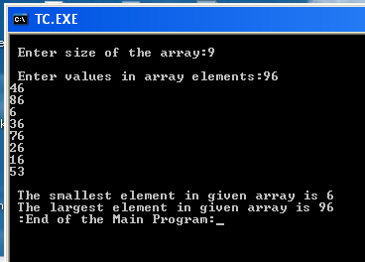

**VIVA QUESTIONS**

1) What is an array ?

2) How many types of arrays are there ?

**5b) Write a C program that uses functions to perform the following:**

**i) Addition of Two Matrices**

**ii) Multiplication of Two Matrices**

**Program-i**

#include <conio.h>

#include <stdio.h>

void init_mat (int [][10], int, int);

void print_mat (int [][10], int, int);

void add_mat (int [][10], int [][10], int [][10], int, int);

main()

{

int r1,r2,c1,c2;

int a[10][10],b[10][10],c[10][10];

clrscr();

printf("\n Enter the order of Matrix – A:");

scanf("%d%d",&r1,&c1);

printf("\n Enter the order of Matrix – B:");

scanf("%d%d",&r2,&c2);

if(r1!=r2 || c1!=c2)

{

printf("\n Matrix Addition is not possible ");

getch();

exit(0);

}

else

{

printf("\n Enter the elements of Matrix – A:");

init_mat(a,r1,c1);

printf("\n The elements of Matrix - A");

print_mat(a,r1,c1);

printf("\n Enter the elements of Matrix - B");

init_mat(b,r2,c2);

printf("\n The elements of Matrix - B");

print_mat(b,r2,c2);

add_mat(a,b,c,r1,c1);

printf("\n The elements of Matrix - C after addition of A & B");

print_mat(c,r1,c1);

}

getch();

}

void init_mat(int mat[][10],int r,int c)

{

int i,j;

for(i=0;i<r;i++)

{

for(j=0;j<c;j++)

{

scanf("%d",&mat[i][j]);

}

}

}

void print_mat(int mat[][10],int r, int c)

{

int i,j;

printf("\n");

for(i=0;i<r;i++)

{

for(j=0;j<c;j++)

{

printf(" %d ",mat[i][j]);

}

printf("\n");

}

}

void add_mat(int a[][10],int b[][10],int c[][10],int r1,int c1)

{

int i,j;

for(i=0;i<r1;i++)

{

for(j=0;j<c1;j++)

{

c[i][j] = a[i][j]+b[i][j];

} } }

**RESULT:**

***Case - 1***

**Input :**

Enter the order of Matrix – A: 2 2

Enter the order of Matrix – B: 2 2

Enter the elements of Matrix – A: 1 2 3 4

The elements of Matrix – A:

1 2

3 4

Enter the elements of Matrix – B: 1 2 3 4

The elements of Matrix – B:24

**Output:**

The elements of Matrix - C after addition of A & B:

2 4

4 8

***Case – 2***

**Input :**

Enter the order of Matrix – A: 2 3

Enter the order of Matrix – B: 2 2

**Output :**

Matrix Addition is not possible

**SCREEN SHOTS**

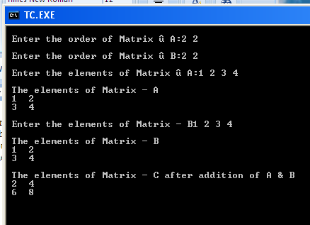

**Program-ii**

#include <stdio.h>

#include <conio.h>

void init_mat (int [][10], int, int);

void print_mat (int [][10], int, int);

void mul_mat (int [][10], int [][10], int [][10], int, int, int);

main()

{

int r1,r2,c1,c2;

int a[10][10],b[10][10],c[10][10];

clrscr();

printf("\n Enter the order of Matrix – A:");

scanf("%d%d",&r1,&c1);

printf("\n Enter the order of Matrix – B:");

scanf("%d%d",&r2,&c2);

if(r1!=c2)

{

printf("\n :: Matrix Multiplication is not possible :: ");

getch();

exit(0);

}

else

{

printf("\n Enter the elements of Matrix – A:");

init_mat(a,r1,c1);

printf("\n The elements of Matrix – A:");

print_mat(a,r1,c1);

printf("\n Enter the elements of Matrix – B:");

init_mat(b,r2,c2);

printf("\n The elements of Matrix – B:");

print_mat(b,r2,c2);

mul_mat(a,b,c,r1,c1,c2);

printf("\n The elements of Matrix - C after multiplication of A & B:");

print_mat(c,r1,c2);

}

getch();

}

void init_mat(int mat[][10],int r,int c)

{

int i,j;

for(i=0;i<r;i++)

{

for(j=0;j<c;j++)

{

scanf("%d",&mat[i][j]);

}

}

}

void print_mat(int mat[][10],int r, int c)

{

int i,j;

printf("\n");

for(i=0;i<r;i++)

{

for(j=0;j<c;j++)

{

printf(" %d ",mat[i][j]);

}

printf("\n");

}

}

void mul_mat(int a[][10],int b[][10],int c[][10],int r1,int c1,int c2)

{

int i,j,k;

for(i=0;i<r1;i++)

{ for(j=0;j<c2;j++)

{

/* Initializing Matrix - C with 0's */

c[i][j] = 0;

/* logic for Multiplication */

for(k=0;k<c1;k++)

{

c[i][j] += a[i][k] * b[k][j];

}

}

}

}

**RESULT:**

***Case - 1***

**Input :**

Enter the order of Matrix – A: 2 2

Enter the order of Matrix – B: 2 2

Enter the elements of Matrix – A: 1 2 3 4

The elements of Matrix – A:

1 2

3 4

Enter the elements of Matrix – B: 1 2 3 4

The elements of Matrix – B: 2 4

**Output:**

The elements of Matrix - C after multiplication of A & B:

7 10

15 22

***Case – 2***

**Input :**

Enter the order of Matrix – A: 2 3

Enter the order of Matrix – B: 1 2

**Output :**

Matrix Multiplication is not possible

SCREEN SHOTS

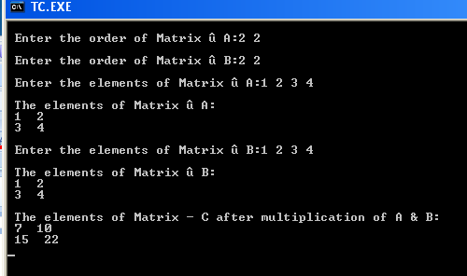

**VIVA QUESTIONS**

1) What is condition for performing an matric addition ?

2) What is condition for performing an matric addition ?

**6a) Write a C program that uses functions to perform the following operations:**

**i) To insert a sub-string in to a given main string from a given position.**

**Program-i**

#include <stdio.h>

#include <conio.h>

void ins_substr(char [], char [], int, int);

/* main function is starting */

main()

{

int p,n,i,j;

char str[50],substr[50];

clrscr();

/* Initializing character array */

puts("\n Enter the String:");

gets(str);

fflush(stdin);

/* Entering the position where you want to insert a substring */

printf("Enter the specific position ");

scanf("%d",&p);

printf("\n Enter the Number of Characters:");

scanf("%d",&n);

fflush(stdin);

puts("\n Enter Sub-String:");

gets(substr);

/* function call to inserting string in main string */

ins_substr(str,substr,p,n);

printf("\n :: End of the main program ::");

getch();

}

/* logic to insert sub string in main string */

void ins_substr(char str[], char substr[], int p, int n)

{

int q,i,j;

q=p-1;

for(i=q,j=n;str[i]!='\0';i++,j++)

substr[j]=str[i];

substr[j]='\0';

for(j=0,i=q;substr[j]!='\0';j++,i++)

str[i]=substr[j];

str[i]='\0';

printf("\n The string after inserting substring :");

puts(str);

}

**RESULT:**

***Case - 1***

**Input :**

Enter the String: KS INSTITUTE OF TECHNOLOGY

Enter the specific position : 3

Enter the Number of Characters: 1

Enter Sub-String: N

**Output :**

The string after inserting substring : KSN INSTITUTE OF TECHNOLOGY

:: End of the main program ::

***Case - 2***

**Input :**

Enter the String: KSN INSTITUTE OF TECH

Enter the specific position : 21

Enter the Number of Characters: 6

Enter Sub-String: NOLOGY

**Output :**

The string after inserting substring : KSN INSTITUTE OF TECHNOLOGY

:: End of the main program ::

***Case - 3***

**Input :**

Enter the String: KSN INSTITUTE TECHNOLOGY

Enter the specific position : 14

Enter the Number of Characters: 2

Enter Sub-String: 0F

**Output :**

The string after inserting substring : KSN INSTITUTE OF TECHNOLOGY

:: End of the main program ::

**SCREEN SHOTS**

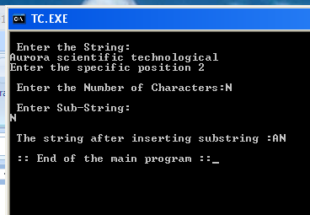

**VIVA QUESTIONS:**

1) Which command is used to delete the strings ?

2) What are the various types of string functions ?

3)What is string ?

4) Which command is used to combined the two strings ?

5) Which command is used to copy the strings ?

**ii) To delete n Characters from a given position in a given string.**

#include <stdio.h>

#include <conio.h>

/* declaring prototype of function */

void del_str(char [],int, int);

/* Main function starting */

main()

{

int n,p;

char str[30];

clrscr();

printf("\n Enter the String::");

gets(str);

fflush(stdin);

printf("\n Enter the position from where the characters are to be deleted:");

scanf("%d",&p);

printf("\n Enter Number of characters to be deleted:");

scanf("%d",&n);

/* function call to deletion of n-characters */

del_str(str,p,n);

printf("::End of the Main program::");

getch();

}

/* function call to Logic of delete n-characters from string */

void del_str(char str[],int p, int n)

{

int i,j;

for(i=0,j=0;str[i]!='\0';i++,j++)

{

if(i==(p-1))

{

i=i+n;

}

str[j]=str[i];

}

str[j]='\0';

/* the string after deletion */

puts(" The string after deletion of characters::");

puts(str);

}

**RESULT:**

***Case - 1***

**Input :**

Enter the String: KSN INSTITUTE OF TECHNOLOGY

Enter the position from where the characters are to be deleted: 5

Enter Number of characters to be deleted: 9

**Output :**

The string after deletion of characters:: KSN OF TECHNOLOGY

:: End of the main program ::

***Case - 2***

**Input :**

Enter the String: KSN INSTITUTE OF TECHNOLOGY

Enter the position from where the characters are to be deleted: 1

Enter Number of characters to be deleted: 3

**Output :**

The string after deletion of characters:: INSTITUTE OF TECHNOLOGY

:: End of the main program ::

***Case - 35***

**Input :**

Enter the String: KSN INSTITUTE OF TECHNOLOGY

Enter the position from where the characters are to be deleted: 27

Enter Number of characters to be deleted: 1

**Output :**

The string after deletion of characters:: KSN INSTITUTE OF TECHNOLOG

:: End of the main program ::

**SCREEN SHOTS**

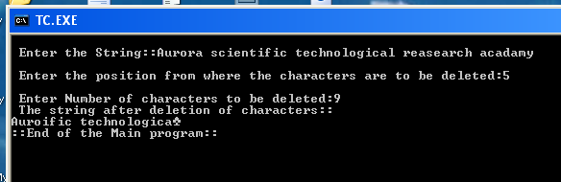

**VIVA QUESTIONS**

1) What is string ?

2) Which command is used to combined the two strings ?

3) Which command is used to copy the strings ?

**6b) Write a C program to determine if the given string is a palindrome or not**

#include <stdio.h>

#include <conio.h>

main()

{

int i,n,j,len=0;

char str[30];

clrscr();

printf("\n Enter String:");

gets(str);

for(i=0;str[i]!='\0';i++)

len++;

printf("\n The length of the string is %d",len);

for(i=0,j=len-1;str[i]!='\0';i++,j--)

{

if(str[i]!=str[j])

{

printf("\n :The given string is not a palindrome:");

getch();

exit(0);

}

}

printf("\n :the given string is palindrome:");

getch();

}

**RESULT:**

***Case - 1***

**Input :**

Enter the String: MALAYALAM

The length of the string is 9

**Output :**

:the given string is palindrome:

**SCREEN SHOTS**

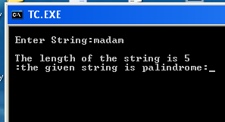

**VIVA QUESTIONS:**

1) Which command is used to delete the strings ?

2) What are the various types of string functions ?

3)what is palindrome?

**7a) Write a C program that displays the position or index in the string S where the string T begins, or – 1 if S doesn’t contain T.**

#include <stdio.h>

#include <conio.h>

#include <string.h>

main()

{

int i,j,n;

char s[40],t[40];

clrscr();

printf("\n Enter the string:");

gets(s);

fflush(stdin);

printf("\n Enter the sub string:");

gets(t);

i=0;

j=0;

while( s[i] != '\0')

{

if((s[i] == t[j]) && (s[i+1] == t[j+1]))

break;

if(i==strlen(s))

{

printf("-1");

getch();

exit(0);

}

i++;

}

j=0;

n=i;

while(t[j] != '\0')

{

if(s[i] == t[j])

{

i++;

j++;

}

else

{

printf("-1");

getch();

exit(0);

} } printf("\n The string is found at %d",n+1);

getch(); }

**RESULT:**

***Case - 1***

**Input :**

Enter the String: BALAJIRAIDU

Enter substring : RAI

**Output :**

The String is found at 7

**SCREEN SHOTS**

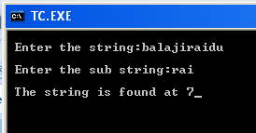

**7b) Write a C program to count the lines, words and characters in a given text.**

#include <conio.h>

#include <stdio.h>

/* Main function is starting */

main()

{

char text[200];

int i,l,ch,w,sp;

clrscr();

/* logic to count number of characters */

i=0;

printf("\n Enter lines of text and press ^Z");

while((text[i]=getchar())!=EOF)

{

i++;

}

printf("\n The number of characters is %d",i);

/* logic to count the lines, words and spaces in text */

text[i]='\0';

l=0;

ch=w=sp=0;

for(i=0;text[i]!='\0';i++)

{

ch++;

if(text[i]==32 && text[i+1] != ' ')

{

w++;

sp++;

}

if(text[i] == '\n')

{

l++;

w++;

}

}

printf("\n Total size of the text : %d",ch);

printf("\n Number of Words : %d",w+1);

printf("\n Number of Lines : %d",l);

printf("\n Number of Spaces : %d",sp);

getch();

}

**Result:**

n Enter lines of text and press ^Z”” BALAJI RAIDU is a HOD of OUR COLLEGE

n Total size of the text: 36

n Number of Words:8

Number of Lines:1

Number of Spaces:7

**SCREEN SHOTS**

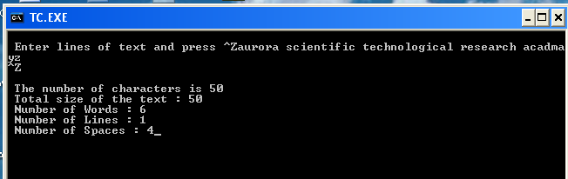

**VIVA QUESTIONS:**

**1) What is the difference between printf() and puts() ?**

**2) define pointer variable ?**

**3) What is use of the strcmp() function ?**

**8a) Write a C program to generate Pascal’s triangle.**

#include <stdio.h>

#include <conio.h>

main()

{

int a[10][10],i,j,k,n;

clrscr();

printf("Enter the height of the pascal traingle");

scanf("%d",&n);

for(i=0;i<n;i++)

{

for(k=1;k<=n-i;k++)

printf(" ");

for(j=0;j<=i;j++)

{

if(j==0 || i==j)

a[i][j]=1;

else

a[i][j]=a[i-1][j-1]+a[i-1][j];

printf("%d ",a[i][j]);

}

printf("\n");

}

}

**Result:**

Enter height of pascal triangle: 2

1

* + 1. 2

**VIVA QUESTIONS**

1.What is meant by Pascal’s triangle ?

2)define structure **?**

**SCREEN SHOTS**

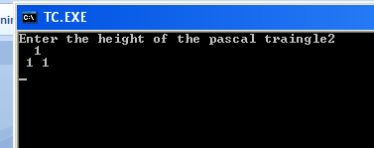

**8b) Write a C program to construct a pyramid of numbers.**

#include <stdio.h>

#include <conio.h>

main()

{

int i,j,k,n;

clrscr();

printf("Enter the height of the pyramid");

scanf("%d",&n);

for(j=0;j<=n;j++)

{

for(k=1;k<=2*(n-j);k++)

printf(" ");

for(i=-j;i<=j;i++)

printf("%d ",abs(i));

printf("\n");

}

}

**Result:**

Enter the height of the pyramid: 2

1

2 2

**SCREEN SHOTS**

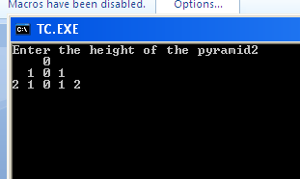

**9.** **Write a C program to read in two numbers, x and n, and then compute the sum of this geometric progression: 1+x+x2+x3+………….+xn For example: if n is 3 and x is 5, then the program computes 1+5+25+125.Print x, n, the sum Perform error checking. For example, the formula does not make sense for negative exponents – if n is less than 0.Have your program print an error message if n<0, then go back and read in the next pair of numbers of without computing the sum. Are any values of x also illegal? If so, test for them too**.

#include <stdio.h>

#include <conio.h>

#include <math.h>

main()

{

int x,n,sum=0,i;

start:

clrscr();

printf("enter the values for x and n");

scanf("%d%d",&x,&n);

if(n>0)

{

for(i=0;i<=n;i++)

{

sum = sum+pow(x,i);

}

printf(“ x is - %d, n is -%d \n”,x,n);

printf("The sum of the geometric progression is:%d",sum);

}

else

{

printf("not a valid n:%d value",n);

getch();

goto start;

}

}

**Result:**

enter the values for x and n 1 1

The sum of the geometric progression: 2

**SCREEN SHOTS**

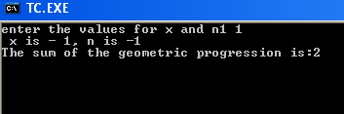

**VIVA QUESTIONS**

1) What is the use of dot operator in structures ?

2) Define unions ?

**10 a) 2’s complement of a number is obtained by scanning it from right to left and complementing all the bits after the first appearance of a 1. Thus 2’s complement of 11100 is 00100. Write a C program to find the 2’s complement of a binary number.**

#include <stdio.h>

#include <conio.h>

#include <string.h>

main()

{

char str[32],strdp[32];

int mask,i;

clrscr();

printf("Enter a binary number:");

scanf("%s",str);

strcpy(strdp,str); /* creating duplicate copy */

for(i=0;i<strlen(str);i++) /* computing 1's complement */

{

if(str[i]=='1')

str[i]='0';

else

str[i]='1';

}

printf("1\'s complement of %s is %s\n",strdp,str);

mask=1;

for(i=strlen(str)-1;i>=0;i--) /* computing 2's complement */

{

if(mask==1)

{

if(str[i]=='1')

{

str[i]='0';

mask=1;

}

else

{

str[i]='1';

mask=0;

}

}

}

printf("2\'s complement of %s is %s",strdp,str);

}

**Result:**

Enter a binary number: 1111

1’s complement is: 0000

2’s complement is: 0001

**SCREEN SHOTS**

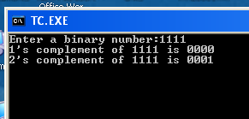

**10b) Write a C program to convert a Roman numeral to its decimal equivalent.**

#include <stdio.h>

#include <conio.h>

main()

{

char roman[30];

int deci=0;

int len,i,d[30];

clrscr();

printf("The following table shows the Roman equivalent to decimal\n");

printf("Decimal:.........Roman\n");

printf("%5d............%3c\n",1,'I');

printf("%5d............%3c\n",5,'V');

printf("%5d............%3c\n",10,'X');

printf("%5d............%3c\n",50,'L');

printf("%5d............%3c\n",100,'C');

printf("%5d............%3c\n",500,'D');

printf("%5d............%3c\n",1000,'M');

printf("Enter a Roman numeral:");

scanf("%s",roman);

len=strlen(roman);

for(i=0;i<len;i++)

{

switch(roman[i])

{

case 'm':

case 'M': d[i]=1000; break;

case 'd':

case 'D': d[i]= 500; break;

case 'c':

case 'C': d[i]= 100; break;

case 'l':

case 'L': d[i]= 50; break;

case 'x':

case 'X': d[i]= 10; break;;

case 'v':

case 'V': d[i]= 5; break;

case 'i':

case 'I': d[i]= 1; }}

for(i=0;i<len;i++)

{ if(i==len-1 || d[i]>=d[i+1])

deci += d[i]; else

deci -= d[i];}printf("The Decimal equivalent of Roman numeral %s is d", roman, deci);}

**Result:**

Enter a Roman numeral: L

The Decimal equivalent of Roman numeral L is :50

**SCREEN SHOTS**

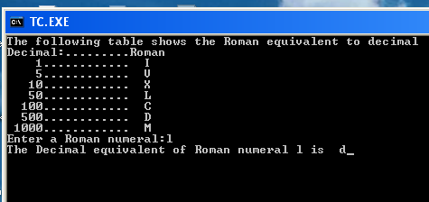

**VIVA QUESTIONS**

1) What is the difference between printf() and puts() ?

2) define pointer variable ?

3) What is use of the strcmp() function ?

**11.Write a C program that uses functions to perform the following operations:**

**i) Reading a complex number**

**ii) Writing a complex number**

**iii) Addition of two complex numbers**

**iv) Multiplication of two complex numbers**

#include <stdio.h>

#include <stdlib.h>

struct compl

{

int x;

int y;

};

typedef struct compl complex;

main()

{

complex c1,c2,c3;

complex add(complex c1,complex c2);

complex sub(complex c1,complex c2);

complex mul(complex c1,complex c2);

complex readcomplex();

complex printcomplex(complex c1,complex c2,complex c3,char op);

char op;

clrscr();

printf("Reading the first complex number\n");

c1=readcomplex();

printf("Reading the second complex number\n");

c2=readcomplex();

printf("Enter + for addition \n"

"Enter * for multiplication\n"

"Enter - for subtraction\n"

"Enter e for exit:");

fflush(stdin);

op=getche();

switch(op)

{

case '+': c3=add(c1,c2);

break;

case '-': c3=sub(c1,c2);

break;

case '*': c3=mul(c1,c2);

break;

case 'e': exit(0);

}

printcomplex(c1,c2,c3,op);

getch();

}

complex add(complex c1,complex c2)

{

complex c3;

c3.x=c1.x+c2.x;

c3.y=c1.y+c2.y;

return(c3);

}

complex sub(complex c1,complex c2)

{

complex c3;

c3.x=c1.x-c2.x;

c3.y=c1.y-c2.y;

return(c3);

}

complex mul(complex c1,complex c2)

{

complex c3;

c3.x=(c1.x*c2.x+c1.y+c2.y)/(c2.x*c2.x+c2.y*c2.y);

c3.y=(c2.x*c1.y-c1.x*c2.y)/(c2.x*c2.x+c2.y*c2.y);

return(c3);

}

complex readcomplex()

{

complex c;

printf("Enter the values of x and y of a complex number");

scanf("%d%d",&c.x,&c.y);

return(c);

}

complex printcomplex(complex c1,complex c2,complex c3,char op)

{

printf("\n(%d+i%d)%c(%d+i%d)=%d+i(%d)",c1.x,c1.y,op,c2.x,c2.y,c3.x,c3.y);

}

**Result:**

Reading the first complex number: 2 + 2i

Reading the second complex number: 2 - 2i

Enter + for addition

"Enter * for multiplication\n"

"Enter - for subtraction\n"

"Enter e for exit : *

Result is: 0

**SCREEN SHOTS**

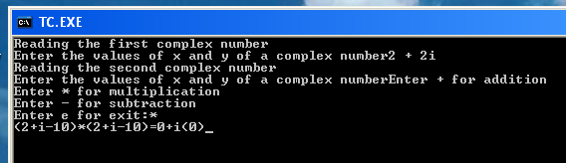

**VIVA QUESTIONS**

1) Expand ASCII ?

2)What is binary number ?

3) Define 2”s complement ?

**12a) Write a C program which copies one file to another.**

**b) Write a C program to reverse the first n characters in a file.**

**A)**

#include <stdio.h>

#include <conio.h>

#include <process.h>

void main(int argc, char *argv[])

{

FILE *fs,*ft;

char ch;

clrscr();

if(argc!=3)

{

puts("Invalid number of arguments.");

exit(0);

}

fs = fopen(argv[1],"r");

if(fs==NULL)

{

puts("Source file cannot be opened.");

exit(0);

}

ft = fopen(argv[2],"w");

if (ft==NULL)

{

puts("Target file cannot be opened.");

fclose(fs);

exit(0);

}

while(1)

{

ch=fgetc(fs);

if (ch==EOF)

break;

else

fputc(ch,ft);

}

fclose(fs);

fclose(ft);

getch();

}

**Result:**

File created is passed as parameter:

File is copied

**B)** #include <stdio.h>

#include <conio.h>

#include <string.h>

#include <process.h>

void main(int argc, char *argv[])

{

char a[15];

char s[20];

char n;

int k;

int j=0;

int i;

int len;

FILE *fp;

if(argc!=3)

{

puts("Improper number of arguments.");

exit(0);

}

fp = fopen(argv[1],"r");

if(fp == NULL)

{

puts("File cannot be opened.");

exit(0);

}

k=atoi(argv[2]);

n = fread(a,1,k,fp);

a[n]='\0';

len=strlen(a);

for(i=len-1;i>=0;i--)

{

s[j]=a[i];

printf("%c",s[j]);

j=j+1;

}

s[j+1]='\0';

getch();

}

**Result:**

Abc.txt: raidu is a good boy

Output: yob doog a si udiar

**VIVA QUESTIONS:**

1) What is file ?

2) What are the various operations performed on the file ?

3) What is the use of file pointer ?

**13a) Write a C program to display the contents of a file.**

**a)**

#include<stdio.h>

void main()

{

FILE *fp;

char ch;

char source[67];

int count = 1;

clrscr();

puts("enter the file name:");

gets(source);

fp=fopen(source,"r");// read only mode for the source file

if(fp==NULL)

{

puts("unable to open the file:");

getch();

exit();

}

clrscr();

printf("file name:%s",source);

printf("\n line:-%d\t",count);

while((ch=getc(fp))!=EOF)

{

if(ch=='\n')

{

count++;

printf("\nline:-%d\t",count);

}

else

{

printf("%c",ch);

}

}

printf("\n press any key...");

getch();

fclose(fp);

}

**RESULT:**

Enter the name of file you wish to see

“Give a path to that file “EG:e:”\astra.c””

**SCREEN SHOTS:**

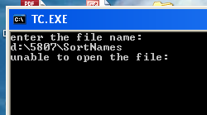

**b) Write a C program to merge two files into a third file .**

#include <stdio.h>

#include <stdlib.h>

int main()

{

FILE *fs1, *fs2, *ft;

char ch, file1[20], file2[20], file3[20];

clrscr();

printf("Enter name of first file\n");

gets(file1);

printf("Enter name of second file\n");

gets(file2);

printf("Enter name of file which will store contents of two files\n");

gets(file3);

fs1 = fopen(file1,"r");

fs2 = fopen(file2,"r");

if( fs1 == NULL || fs2 == NULL )

{

perror("Error ");

printf("Press any key to exit...\n");

getch();

exit(EXIT_FAILURE);

}

ft = fopen(file3,"w");

if( ft == NULL )

{

perror("Error ");

printf("Press any key to exit...\n");

exit(EXIT_FAILURE);

}

while( ( ch = fgetc(fs1) ) != EOF )

fputc(ch,ft);

while( ( ch = fgetc(fs2) ) != EOF )

fputc(ch,ft);

printf("Two files were merged into %s file successfully.\n",file3);

fclose(fs1);

fclose(fs2);

fclose(ft);

return 0;

}

**RESULT**

Enter a first file:data.c

Enter a Second file:fact.c

The Merged file is data-fact.c

“the content in file one and second is copied into new file”

**SCREEN SHOTS**

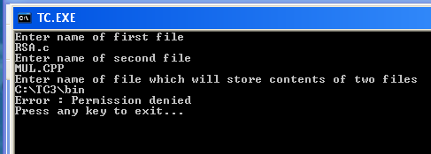

**Viva questions:**

1) What is file ?

2) What are the various operations performed on the file ?

3) What is the use of file pointer ?

**14a) Write a C program that uses non recursive function to search for a Key value in a given list of integers using Linear search.**

#include <stdio.h>

#include <conio.h>

#define MAX_LEN 10

void linearSearch(int l[],int num,int ele);

void read_list(int l[],int num);

void print_list(int l[],int num);

int main()

{

int l[MAX_LEN], num, ele;

printf("Enter the number of elements :");

scanf("%d",&num);

read_list(l,num);

printf("\nElements present in the list are:\n\n");

print_list(l,num);

printf("\n**Non-Recursion method**\n");

printf("\n\nElement you want to search:\n\n");

scanf("%d",&ele);

linearSearch(l,num,ele);

getch();

}

void linearSearch(int l[],int num,int ele)

{

int j, f=0;

for(j=0; j<num; j++)

if( l[j] == ele)

{

printf("\nThe element %d is present at position %d in list\n",ele,j);

f=1;

break;

}

if(f==0)

printf("\nThe element is %d is not present in the list\n",ele);

}

void read_list(int l[],int num)

{

int j;

printf("\nEnter the elements:\n");

for(j=0; j<num; j++)

scanf("%d",&l[j]);

}

void print_list(int l[],int num)

{

int j;

for(j=0; j<num; j++)

printf("%d\t",l[j]);}

**RESULT:**

Enter Size

5

Enter 5 elements 12

30

25

4

85

The array elements 12 30 25 4 85

Enter elements to search 25

The elements 25 found at location 3

**SCREEN SHOTS**

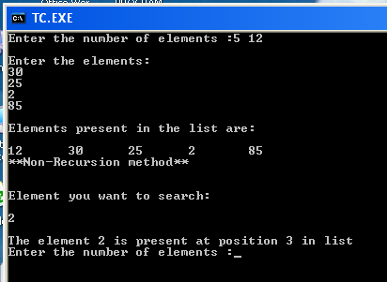

**Viva questions**

1) Define Stack ?

2) Define data structure ?

3) What are the various operation performed on the stack ?

**15a) Write a C program that implements the Selection sort method to sort a given array of integers in ascending order.**

#include<stdio.h>

int main(){

int s,i,j,temp,a[20];

printf("Enter total elements: ");

scanf("%d",&s);

printf("Enter %d elements: ",s);

for(i=0;i<s;i++)

scanf("%d",&a[i]);

for(i=0;i<s;i++){

for(j=i+1;j<s;j++){

if(a[i]>a[j]){

temp=a[i];

a[i]=a[j];

a[j]=temp;

}

}

}

printf("After sorting is: ");

for(i=0;i<s;i++)

printf(" %d",a[i]);

return 0;

}

**RESULT**

Enter total elements: 5

Enter 5 elements: 4 5 0 21 7

The array after sorting is: 0 4 5 7 21

**SCREEN SHOTS**

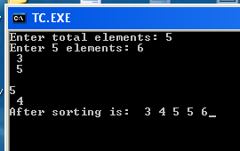

**VIVA QUESTIONS**

1) Define Binary tree ?

2) How many ways a tree can be traversed ?

3) define graph ?

**15b) Write a C program that implements the Bubble sort method to sort a given list of names**

**in ascending order**

#include<stdio.h>

#include<conio.h>

void main()

{

int n, a[20], temp, i, j;

clrscr();

printf("Enter the size of the array\n");

scanf("%d", &n);

printf("Enter the array elements\n");

for(i = 0; i < n; i++)

{

scanf("%d", &a[i]);

}

for(i = 0; i < n - 1; i++)

{

for(j = 0; j < n - 1; j++)

{

if(a[j] > a[j + 1])

{

temp = a[j];

a[j] = a[j + 1];

a[j + 1] = temp;

}

}

}

printf("The sorted array is\n");

for(i = 0; i < n; i++)

printf("%d\n", a[i]);

getch();

}

Output:

Enter total numbers of elements: 5

Enter 5 elements: 6 2 0 11 9

After sorting: 0 2 6 9 11

**RESULT:**

Enter the size of the array: 5

Enter the array elements: 50 40 30 20 10

The sorted array is: 10 20 30 40 50

**SCREEN SHOTS**

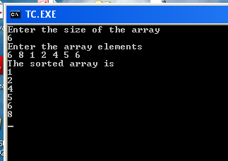

**VIVA QUESTIONS**

1) Define bubble sort ?

2) display the efficiency of bubble sort ?

**16.Write a C program that uses functions to perform the following operations:**

**i) Create a singly linked list of integer elements.**

**ii) Traverse the above list and display the elements.**

i)

#include<stdio.h>

#include<stdlib.h>

#include<string.h>

struct info

{

char name[30];

int eno;

struct info *next;

};

struct info *head=NULL,*temp,*disp;

void addrecord();

void deleterecord();

void disrecord();

void main()

{

int ch;

clrscr();

while (1)

{

printf("\n 1. To add records\n");

printf("\n 2. To delete a records\n");

printf("\n 3. To view the records\n");

printf("\n 4. To exit\n");

printf("\n Enter your choice\n");

scanf("%d",&ch);

fflush(stdin);

switch(ch)

{

case 1:addrecord();

break;

case 2:deleterecord();

break;

case 3: disrecord();

break;

case 4:exit(0);

}

}

}

void addrecord()

{

struct info *add;

char ans='y';

while (ans=='y')

{

add=(struct info*)malloc(sizeof(struct info));

printf("\n Enter the names:\n");

gets(add->name);

fflush(stdin);

printf("\n Enter the enrollment number:\n");

scanf("%d",&add->eno);

fflush(stdin);

if (head==NULL)

{

head=add;

add->next=NULL;

temp=add;

}

else

{

temp->next=add;

add->next=NULL;

temp=add;

}

printf("\n Would you like to enter another name(y\\n): \n");

ans = getchar();

fflush(stdin);

}

}

void deleterecord()

{

struct info *delete;

int teno, present=0;

if (head==NULL)

{

printf("\n No records to delete\n");

return;

}

printf("\n Enter the enrollment number to be deleted \n");

scanf("%d",&teno);

fflush(stdin);

for (delete=head;delete!=NULL;delete=delete->next)

{

if (delete->eno==teno)

{

if (head->eno==teno)

{

delete=head;

head=head->next;

free(delete);

return;

}

else

{

temp->next=delete->next;

free(delete);

return;

}

}

temp=delete;

}

if (present==0)

printf("\nNo such enrollment number present\n");

}

void disrecord()

{

if (head==NULL)

{

printf("\n No records to view\n");

return;

}

for (disp=head;disp!=NULL;disp=disp->next)

{

printf("\n\n Name : %s",disp->name);

printf("\n\n Number : %d",disp->eno);

}

}

**VIVA QUESTIONS:**

1) List out the memory allocation functions ?

2) Define linked list ?

3) List out the advantages of linked list ?

**17.Write a C program that implements stack (its operations) using a singly linked list to display**

**a given list of integers in reverse order. Ex. input: 10 23 4 6 output: 6 4 23 10**

#include <stdlib.h>

typedef struct node

{

int data;

struct node *link;

}NODE;

void Push(int);

int pop();

void Display();

NODE *top=NULL; /* Global Declarations */

main()

{

/* Main Program */

int opn,elem;

do

{

clrscr();

printf("\n ### Linked List Implementation of STACK Operations ### \n\n");

printf("\n Press 1-Push, 2-Pop, 3-Display,4-Exit\n");

printf("\n Your option ? ");

scanf("%d",&opn);

switch(opn)

{

case 1:

printf("\n\nRead the Element tobe pushed ?");

scanf("%d",&elem);

Push(elem);

break;

case 2:

elem=Pop();

if(elem != -1)

printf(" Deleted Node(From Top)with the Data: %d\n",elem);

break;

case 3: printf("Linked List Implementation of Stack: Status:\n");

Display(); break;

case 4: printf("\n\n Terminating \n\n"); break;

default: printf("\n\nInvalid Option !!! Try Again !! \n\n");

break;

}

printf("\n\n\n\n Press a Key to Continue . . . ");

getch();

}while(opn != 4);

}

void Push(int info)

{

NODE *temp;

temp=(NODE *)malloc(sizeof(NODE));

if( temp == NULL)

printf(" Out of Memory !! Overflow !!!");

else

{

temp->data=info;

temp->link=top;

top=temp;

printf(" Node has been inserted at Top(Front) Successfully !!");

}

}

int Pop()

{

int info;

NODE *t;

if( top == NULL) { printf(" Underflow!!!"); return -1; }

else

{

t=top;

info=top->data;

top=top->link;

t->link=NULL;

free(t);

return(info);

}

}

void Display()

{

NODE *t;

if( top == NULL) printf("Empty Stack\n");

else

{

t=top;

printf("Top->");

while(t)

{

printf("[%d]->",t->data);

t=t->link;

}

printf("Null\n");

}}

**output**

1 - Push

2 - Pop

3 - Top

4 - Empty

5 - Exit

6 - Dipslay

7 - Stack Count

8 - Destroy stack

Enter choice : 1

Enter data : 56

Enter choice : 1

Enter data : 80

Enter choice : 2

Popped value : 80

Enter choice : 3

Top element : 56

Enter choice : 1

Enter data : 78

Enter choice : 1

Enter data : 90

Enter choice : 6

90 78 56

Enter choice : 7

No. of elements in stack : 3

Enter choice : 8

All stack elements destroyed

Enter choice : 4

Stack is empty

**SCREEN SHOTS**

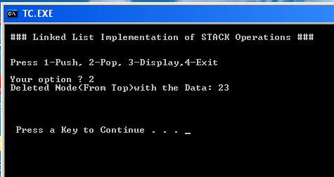

**VIVA QUESTIONS:**

1) List out the memory allocation functions ?

2) Define linked list ?

3) List out the advantages of linked list ?

**18. Write a C program that implements Queue (its operations) using a singly linked list to display a given list of integers in the same order. Ex. input: 10 23 4 6 output: 10 23 4 6**

#include <stdlib.h>

typedef struct node

{

int data;

struct node *link;

}NODE;

void Insert(int);

int Delete();

void Display();

NODE *front,*rear; /* Global Declarations */

main()

{

/* Main Program */

int opn,elem;

front=rear=NULL;

do

{

clrscr();

printf("\n ### Linked List Implementation of QUEUE Operations ### \n\n");

printf("\n Press 1-Insert, 2-Delete, 3-Display,4-Exit\n");

printf("\n Your option ? ");

scanf("%d",&opn);

switch(opn)

{

case 1:

printf("\n\nRead the Element to be Inserted ?");

scanf("%d",&elem);

Insert(elem);

break;

case 2:

elem=Delete();

if(elem != -1)

printf(" Deleted Node(From Front)with the Data: %d\n",elem);

break;

case 3: printf("Linked List Implementation of Queue: Status:\n");

Display(); break;

case 4: printf("\n\n Terminating \n\n"); break;

default: printf("\n\nInvalid Option !!! Try Again !! \n\n");

break;

}

printf("\n\n\n\n Press a Key to Continue . . . ");

getch();

}while(opn != 4);

}

void Insert(int info)

{

NODE *temp;

temp=(NODE *)malloc(sizeof(NODE));

if( temp == NULL)

printf(" Out of Memory !! Overflow !!!");

else

{

temp->data=info;

temp->link=NULL;

if(front == NULL) { front = rear = temp; } /* First Node? */

else

{ rear->link=temp; rear = temp; } /* Insert End */

printf(" Node has been inserted at End Successfully !!");

}

}

int Delete()

{

int info;

NODE *t;

if( front == NULL) { printf(" Underflow!!!"); return -1; }

else

{

t=front;

info=front->data;

if(front == rear) rear=NULL;

front=front->link;

t->link=NULL;

free(t);

return(info);

}

}

void Display()

{

NODE *t;

if( front == NULL) printf("Empty Queue\n");

else

{

t=front;

printf("Front->");

while(t)

{

printf("[%d]->",t->data);

t=t->link;

}

printf("Rear\n");

}

}

**Output**

1 - Enque

2 - Deque

3 - Front element

4 - Empty

5 - Exit

6 - Display

7 - Queue size

Enter choice : 1

Enter data : 14

Enter choice : 1

Enter data : 85

Enter choice : 1

Enter data : 38

Enter choice : 3

Front element : 14

Enter choice : 6

14 85 38

Enter choice : 7

Queue size : 3

Enter choice : 2

Dequed value : 14

Enter choice : 6

85 38

Enter choice : 7

Queue size : 2

Enter choice : 4

Queue not empty

Enter choice : 5

**SCREEN SHOTS**

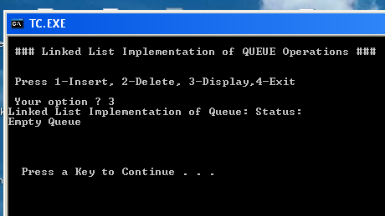

**19. Write a C program to implement the linear regression algorithm**

#include<stdio.h>

#include<conio.h>

#include<math.h>

#include<string.h>

float mean(float *a, int n);

void deviation(float *a, float mean, int n, float *d, float *S);

void main()

{

float a[20],b[20],dx[20],dy[20];

float sy=0,sx=0,mean_x=0,mean_y=0,sum_xy=0;

float corr_coff=0,reg_coff_xy=0, reg_coff_yx=0;

char type_coff[7];

int n=0,i=0;

clrscr();

printf("Enter the value of n: ");

scanf("%d",&n);

printf("Enter the values of x and y:\n");

for(i=0;i<n;i++)

scanf("%f%f",&a[i],&b[i]);

mean_x=mean(a,n);

mean_y=mean(b,n);

deviation(a,mean_x,n,dx,&sx);

deviation(b,mean_y,n,dy,&sy);

for(i=0;i<n;i++)

sum_xy=sum_xy+dx[i]*dy[i];

corr_coff=sum_xy/(n*sx*sy);

printf("Enter the type of regression <span id="IL_AD7" class="IL_AD">coefficient</span> as 'x on y' or 'y on x': ");

fflush(stdin);

gets(type_coff);

if(strcmp(type_coff,"x on y")==1)

{

reg_coff_xy=corr_coff*(sx/sy);

printf("\nThe value of linear regression coefficient is %f",reg_coff_xy);

}

else if(strcmp(type_coff,"y on x")==1)

{

reg_coff_yx=corr_coff*(sy/sx);

printf("\nThe value of linear regression coefficient is %f",reg_coff_yx);

}

else

printf("\nEnter the correct type of regression coefficient.");

getch();

}

float mean(float *a, int n)

{

float sum=0, i=0;

for(i=0;i<n;i++)

sum=sum+a[i];

sum=sum/n;

return (sum);

}

void deviation(float *a, float mean, int n, float *d, float *s)

{

float sum=0,t=0;

int i=0;

for(i=0;i<n;i++)

{

d[i]=a[i]-mean;

t=d[i]*d[i];

sum=sum+t;

}

sum=sum/n;

*s=sqrt(sum);

}

**Output**

How many values You are Entering7

Enter coressponding Elements X & Y

1 0.5

2 2.5

3 2

4 4

5 3.5

6 6

7 5.8

Y=-0.371429+0.871429X

**VIVA QUESTIONS**

1) Define Stack ?

2) Define data structure ?

3) What are the various operation performed on the stack ?

**20.Write a C program to implement the polynomial regression algorithm.**

#include<stdio.h>

#include<conio.h>

#include<math.h>

#include<string.h>

float mean(float *a, int n);

void deviation(float *a, float mean, int n, float *d, float *S);

void main()

{

float a[20],b[20],dx[20],dy[20];

float sy=0,sx=0,mean_x=0,mean_y=0,sum_xy=0;

float corr_coff=0,reg_coff_xy=0, reg_coff_yx=0;

char type_coff[7];

int n=0,i=0;

clrscr();

printf(“Enter the value of n: “);

scanf(“%d”,&n);

printf(“Enter the values of x and y:\n”);

for(i=0;i<n;i++)

scanf(“%f%f”,&a[i],&b[i]);

mean_x=mean(a,n);

mean_y=mean(b,n);

deviation(a,mean_x,n,dx,&sx);

deviation(b,mean_y,n,dy,&sy);

for(i=0;i<n;i++)

sum_xy=sum_xy+dx[i]*dy[i];

corr_coff=sum_xy/(n*sx*sy);

printf(“Enter the type of regression coefficient as ‘x on y’ or ‘y on x': “);

fflush(stdin);

gets(type_coff);

if(strcmp(type_coff,”x on y”)==1)

{

reg_coff_xy=corr_coff*(sx/sy);

printf(“\nThe value of linear regression coefficient is %f”,reg_coff_xy);

}

else if(strcmp(type_coff,”y on x”)==1)

{

reg_coff_yx=corr_coff*(sy/sx);

printf(“\nThe value of linear regression coefficient is %f”,reg_coff_yx);

}

else

printf(“\nEnter the correct type of regression coefficient.”);

getch();

}

float mean(float *a, int n)

{

float sum=0, i=0;

for(i=0;i<n;i++)

sum=sum+a[i];

sum=sum/n;

return (sum);

}

void deviation(float *a, float mean, int n, float *d, float *s)

{

float sum=0,t=0;

int i=0;

for(i=0;i<n;i++)

{

d[i]=a[i]-mean;

t=d[i]*d[i];

sum=sum+t;

}

sum=sum/n;

*s=sqrt(sum);

}

**OUTPUT**

Enter the n values 7

1 2

2 5

4 7

5 10

6 12

8 15

9 19

Y = 1.980769x + 0.096154

**SCREEN SHOT**

Enter the n value 7

1                2

2                5

4                7

5                10

6                12

8                15

9                19

Y = 1.980769x + 0.096154

**VIVA QUESTIONS**

1) What is the use of goto statement ?

2) What is the use of continue statement ?

**21.Write a C program to implement the Lagrange interpolation**

#include<stdio.h>

#include<conio.h>

#define MaxN 90

void main()

{

float arr_x[MaxN+1], arr_y[MaxN+1], numerator, denominator, x, y=0;

int i, j, n;

clrscr();

printf("Enter the value of n: \n");

scanf("%d", &n);

printf("Enter the values of x and y: \n");

for(i=0; i<=n; i++)

scanf("%f%f", &arr_x[i], &arr_y[i]);

printf("Enter the value of x at which value of y is to be calculated: ");

scanf("%f", &x);

for (i=0; i<=n; i++)

{

numerator=1;

denominator=1;

for (j=0; j<=n; j++)

if(j!=i)

{

numerator *= x-arr_x[j];

denominator *= arr_x[i]-arr_x[j];

}

y+=(numerator/denominator)*arr_y[i];

}

printf("When x=%4.1f y=%7.1f\n",x,y);

getch();

}

**SCREEN SHOTS**

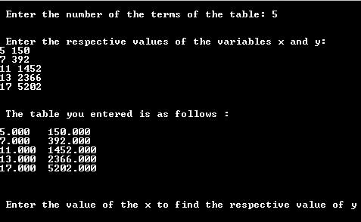

**22. Write C program to implement the Newton- Gregory forward interpolation**.

#include<stdio.h>

#include<conio.h>

#define MaxN 100

#define Order_of_diff 4

void main ()

{

float arr_x[MaxN+1], arr_y[MaxN+1], numerator=1.0, denominator=1.0, x, y, p, h, diff_table[MaxN+1][Order_of_diff+1];

int i,j,n,k;

clrscr();

printf("Enter the value of n \n");

scanf("%d",&n);

printf("Enter the values of x and y");

for(i=0; i<=n; i++)

scanf("%f%f", &arr_x[i], &arr_y[i]);

printf("Enter the value of x at which value of y is to be calculated");

scanf("%f", &x);

h=arr_x[1]-arr_x[0];

for(i=0; i<=n-1; i++)

diff_table[i][1]=arr_y[i+1]-arr_y[i];/*Creating the difference table and calculating first order differences*/

for(j=2; j<=Order_of_diff; j++)/*Calculating higher order differences*/

for(i=0; i<=n-j; i++)

diff_table[i][j]=diff_table[i+1][j-1] - diff_table[i][j-1];

i=0;

while(!(arr_x[i]>x)) /* Finding x0 */

i++;

i--;

p=(x-arr_x[i])/h;

y=arr_y[i];

for (k=1; k<=Order_of_diff; k++)

{

numerator *=p-k+1;

denominator *=k;

y +=(numerator/denominator)*diff_table[i][k];

}

printf("When x=%6.1f, y=%6.2f\n",x, y);

getch();

}

OUTPUT

Enter the value of n 4

Enter the value to be found 2.5

Enter the values for xi’s & fi’s

1 1

2 8

3 27

4 64

X = 2.500000

Sum = 15.625000

**SCREEN SHOTS**

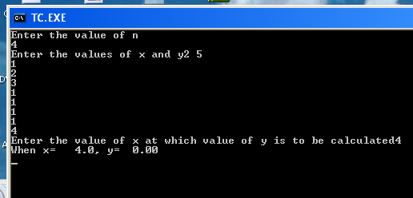

**VIVA QUESTIONS**

1) Define storage class ?

**23. Write a C program to implement Trapezoidal method**

#include<stdio.h>

#include<math.h>

float f(float);

float a; float b; float x; float h; float sum; int n; int i;

int main()

{ clrscr();

printf("Enter value for A:");

scanf("%f",&a);

printf("Enter value for B:");

scanf("%f",&b);

printf("Enter number of rectangles:");

scanf("%d",&n);

h=(b-a)/n;

sum=(0.5*h)*(f(a)+f(b));

printf("%f \n",sum);

for(i=1;i<n;i++)

{

sum=sum+h*f(a+(i*h));

printf("%f \n",sum);

}

printf("The value of the integral is:%f\n",sum);

getch();

}

float f(float x)

{

float value;

value=x*x+3;

return value;

}

Output:

Enter value for A:25

Enter value for B:30

Enter number of rectangles:12

318.958313

589.377869

868.695007

1157.054321

1454.600586

1761.478516

2077.832764

2403.807861

2739.548584

3085.199707

3440.905762

3806.811523

The value of the integral is:3806.811523

**SCREEN SHOTS**

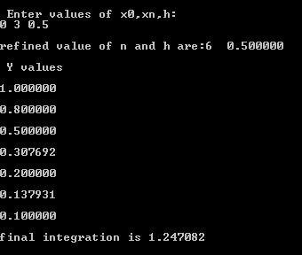

**24 Write a C program to implement Simpson method.**

#include<stdio.h>

#include<conio.h>

#include<math.h>

char postfix[80];

float stack[80];

char stack1[80];

int top=-1,top1=-1;

float eval(char postfix[], float x1);

void infix_postfix(char infix[]);

main()

{

float x0, xn, h, s,e1,e2, e3;

char exp[80], arr[80];

int i,n,l=0;

clrscr();

printf("\nEnter an expression: ");

gets(exp);

puts("Enter x0, xn and number of sub-intervals: ");

scanf("%f%f%d", &x0, &xn, &n);

h=(xn-x0)/n;

if(exp[0]=='l'&& exp[1]=='o'&& exp[2]=='g')

{

l=strlen(exp);

for(i=0;i<l-3; i++)

arr[0]=exp[i+3];

arr[i]='\0';

infix_postfix(arr);

e1=eval(postfix,x0);

e2=eval(postfix,xn);

e3=4*eval(postfix, x0+h);

s=log(e1)+log(e2)+log(e3);

for (i=3;i<=n-1;i+=2)

s+=4*eval(postfix,x0+i*h)+2*eval(postfix, x0+(i-1)*h);

}

else

{

infix_postfix(exp);

s=eval(postfix,x0)+eval(postfix,xn)+4*eval(postfix, x0+h);

for (i=3;i<=n-1;i+=2)

s+=4*eval(postfix,x0+i*h)+2*eval(postfix, x0+(i-1)*h);

}

printf("The value of integral is %6.3f\n",(h/3)*s);

return(0);

}

void push(float item)

{

if(top==99)

{

printf("\n\tThe stack is full");

getch();

exit(0);

}

else

{

top++;

stack[top]=item;

}

return;

}

float pop()

{

float item;

if(top==-1)

{

printf("\n\tThe stack is empty\n\t");

getch();

}

item=stack[top];

top--;

return (item);

}

void push1(char item)

{

if(top1==79)

{

printf("\n\tThe stack is full");

getch();

exit(0);

}

else

{

top1++;

stack1[top1]=item;

}

return;

}

char pop1()

{

char item;

if(top1==-1)

{

printf("\n\tThe stack1 is empty\n\t");

getch();

}

item=stack1[top1];

top1--;

return (item);

}

void infix_postfix(char infix[])

{

int i=0,j=0,k;

char ch;

char token;

for(i=0;i<79;i++)

postfix[i]=' ';

push1('?');

i=0;

token=infix[i];

while(token!='\0')

{

if(isalnum(token))

{

postfix[j]=token;

j++;

}

else if(token=='(')

{

push1('(');

}

else if(token==')')

{

while(stack1[top1]!='(')

{

ch=pop1();

postfix[j]=ch;

j++;

}

ch=pop1();

}

else

{

while(ISPriority(stack1[top1])>=ICP(token))

{

ch=pop1();

postfix[j]=ch;

j++;

}

push1(token);

}

i++;

token=infix[i];

}

while(top1!=0)

{

ch=pop1();

postfix[j]=ch;

j++;

}

postfix[j]='\0';

}

int ISPriority(char token)

{

switch(token)

{

case '(':return (0);

case ')':return (9);

case '+':return (7);

case '-':return (7);

case '*':return (8);

case '/':return (8);

case '?':return (0);

default: printf("Invalid expression");

}

return 0;

}

**SCREEN SHOTS**

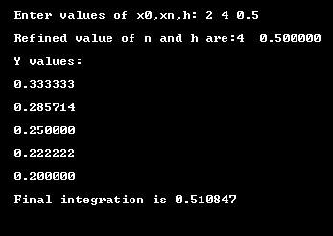

**VIVA QUESTIONS**

1) Define Binary search ?